The Main Title of the Paper
First Author Name^{*1}, Second Author Name²
1 First Author Affliation
2 Second Author Affliation

Abstract
The abstract of article should write here‎. ‎The numbered displayed formulas‎, ‎figures‎, ‎tables and references‎
‎should not be included in the abstract‎. ‎The abstract should be informative so that it briefly describes‎ ‎the research works of the author(s).

Keywords: Most important keywords of article should bring here.

1 Introduction
‎This document gives guidelines for preparing a Word format of the papers to be presented at the 5nd national seminar on control and optimization‎. Papers should be at most four pages long‎. ‎Papers which are not in the required format or more than four pages in length will be returned‎.
‎Here you should bring the preliminaries‎, ‎terminologies‎, ‎historical background‎, ‎definitions and some of the known results‎.
2 Title of the Second Section
‎In this section‎, ‎you discuss the main results of your paper‎. ‎The format for definitions‎, ‎examples‎, ‎lemmas‎, ‎theorems‎, ‎proofs‎, ‎propositions‎, ‎corollaries‎, ‎remarks and algorithms should appear as below‎.
Lemma 2.1. Assume that ….
Example 2.2. Let and ….
Theorem 2.3. If … then

3 Tables
A sample table is shown below. Table 2 has four rows and three columns.

Table 2. Title of table
Column 1 | Column 2 | Column 3
1 | 25 | 7
2 | 0.2 | 0.3
3 | 1 | -3
4 | 0 | 8

4 Figures
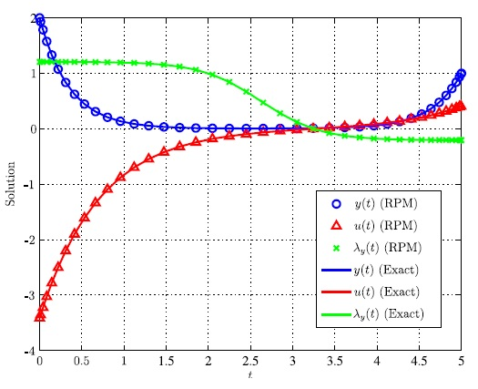
Figure 1. Write the caption here.

‎5 Citation and Reference‎
‎References must be cited in the text‎.
‎The distribution functions estimated by these empirical estimators are discrete[1]‎, ‎however‎, ‎and may be truncated due to censoring‎. ‎Moreover‎, ‎these estimators usually do not provide information for lifetimes outside the data's range‎. ‎For example‎, ‎it may be impossible to estimate the tails of the distribution functions using these empirical estimators [2]‎. ‎Nonparametric Bayesian methods have been considered as attractive methods in reliability models‎. ‎They perform a Bayesian analysis of the failure time data using a likelihood function that is not suggested by any standard model used in reliability‎. ‎The general strategy is to place a prior distribution on the class of all distribution functions‎, ‎and then use the lifetime data to obtain a posterior distribution on this class [3]‎.

6 Discussion and Resuls
‎Conclusion of the paper should be short‎.

Acknowledgement
Acknowledgements could be placed at the end of the text but precede the references.
References
[1] Arjas E‎. ‎and Gasbarra D‎. ‎(1994)‎, ‎Nonparametric Bayesian inference‎ ‎from right sensored survival data‎, ‎using the Gibbs sampler‎, ‎Stat Sin, 4, ‎505-524‎.

‎[2] Ebeling C.E‎. ‎(2010)‎, An introduction to reliability and maintainability‎ ‎engineering‎, ‎2nd ed.‎, ‎Waveland Press Inc.‎, ‎Long Grove‎, ‎IL‎.

‎[3] Singpurwalla N‎. ‎D‎. ‎(2006)‎, Reliability and risk‎: ‎A Bayesian perspective‎‎, ‎England‎, ‎Wiley‎.

